JAVA DOCUMENTATION

PROJECT 1 DOCUMENTATION
Project Name
Number Guessing Game
Objective
The objective of this project is to develop an interactive Number Guessing Game using Java. The program generates a random number between 1 and 100, and the user must guess the correct number within a limited number of attempts. The game provides hints after each guess and maintains a score based on performance.
Introduction
The Number Guessing Game is a simple Java application that demonstrates the use of random number generation, loops, conditional statements, and user input handling. The program creates an engaging experience by allowing users to play multiple rounds and track their scores.
Tools and Technologies Used
- Java
- JDK (Java Development Kit)
- VS Code / IntelliJ IDEA
- Scanner Class
- Random Class
Key Features
- Random number generation between 1 and 100
- Seven attempts per round
- Hint system (Too High / Too Low)
- Input validation
- Score calculation
- Multiple rounds of gameplay
- Replay option
- User-friendly interface
Algorithm
- Start the program.
- Generate a random number between 1 and 100.
- Give the user seven attempts to guess the number.
- Accept user input.
- Validate the entered value.
- Compare the guessed number with the generated number.
- Display hints if the guess is incorrect.
- Award points when the user guesses correctly.
- Display the correct number if all attempts are exhausted.
- Ask the user whether they want to play another round.
- Display the final score and terminate the program.
Concepts Used
- Variables
- Loops (while, do-while)
- Conditional Statements (if-else)
- Random Number Generation
- User Input Handling
- Score Management
Output Screenshot
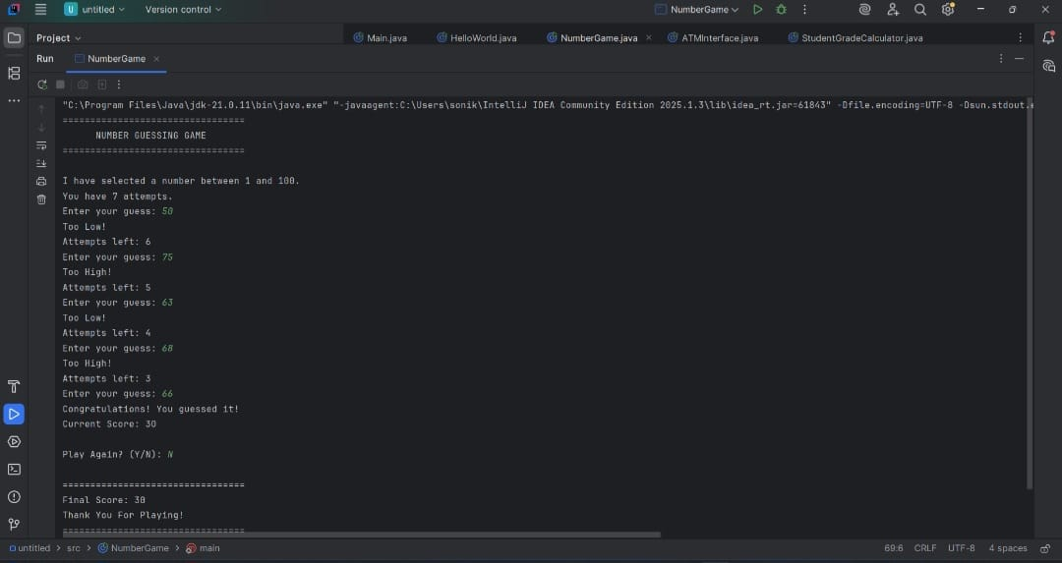

Advantages
- Easy to use
- Interactive gameplay
- Improves logical thinking
- Demonstrates fundamental Java concepts
- Suitable for beginners
Conclusion
The Number Guessing Game was successfully developed using Java. The project demonstrates the practical implementation of loops, conditional statements, random number generation, and user interaction. It provides an engaging user experience while strengthening fundamental programming skills and problem-solving abilities.

